Appendix C

i/ EAGLE schematic

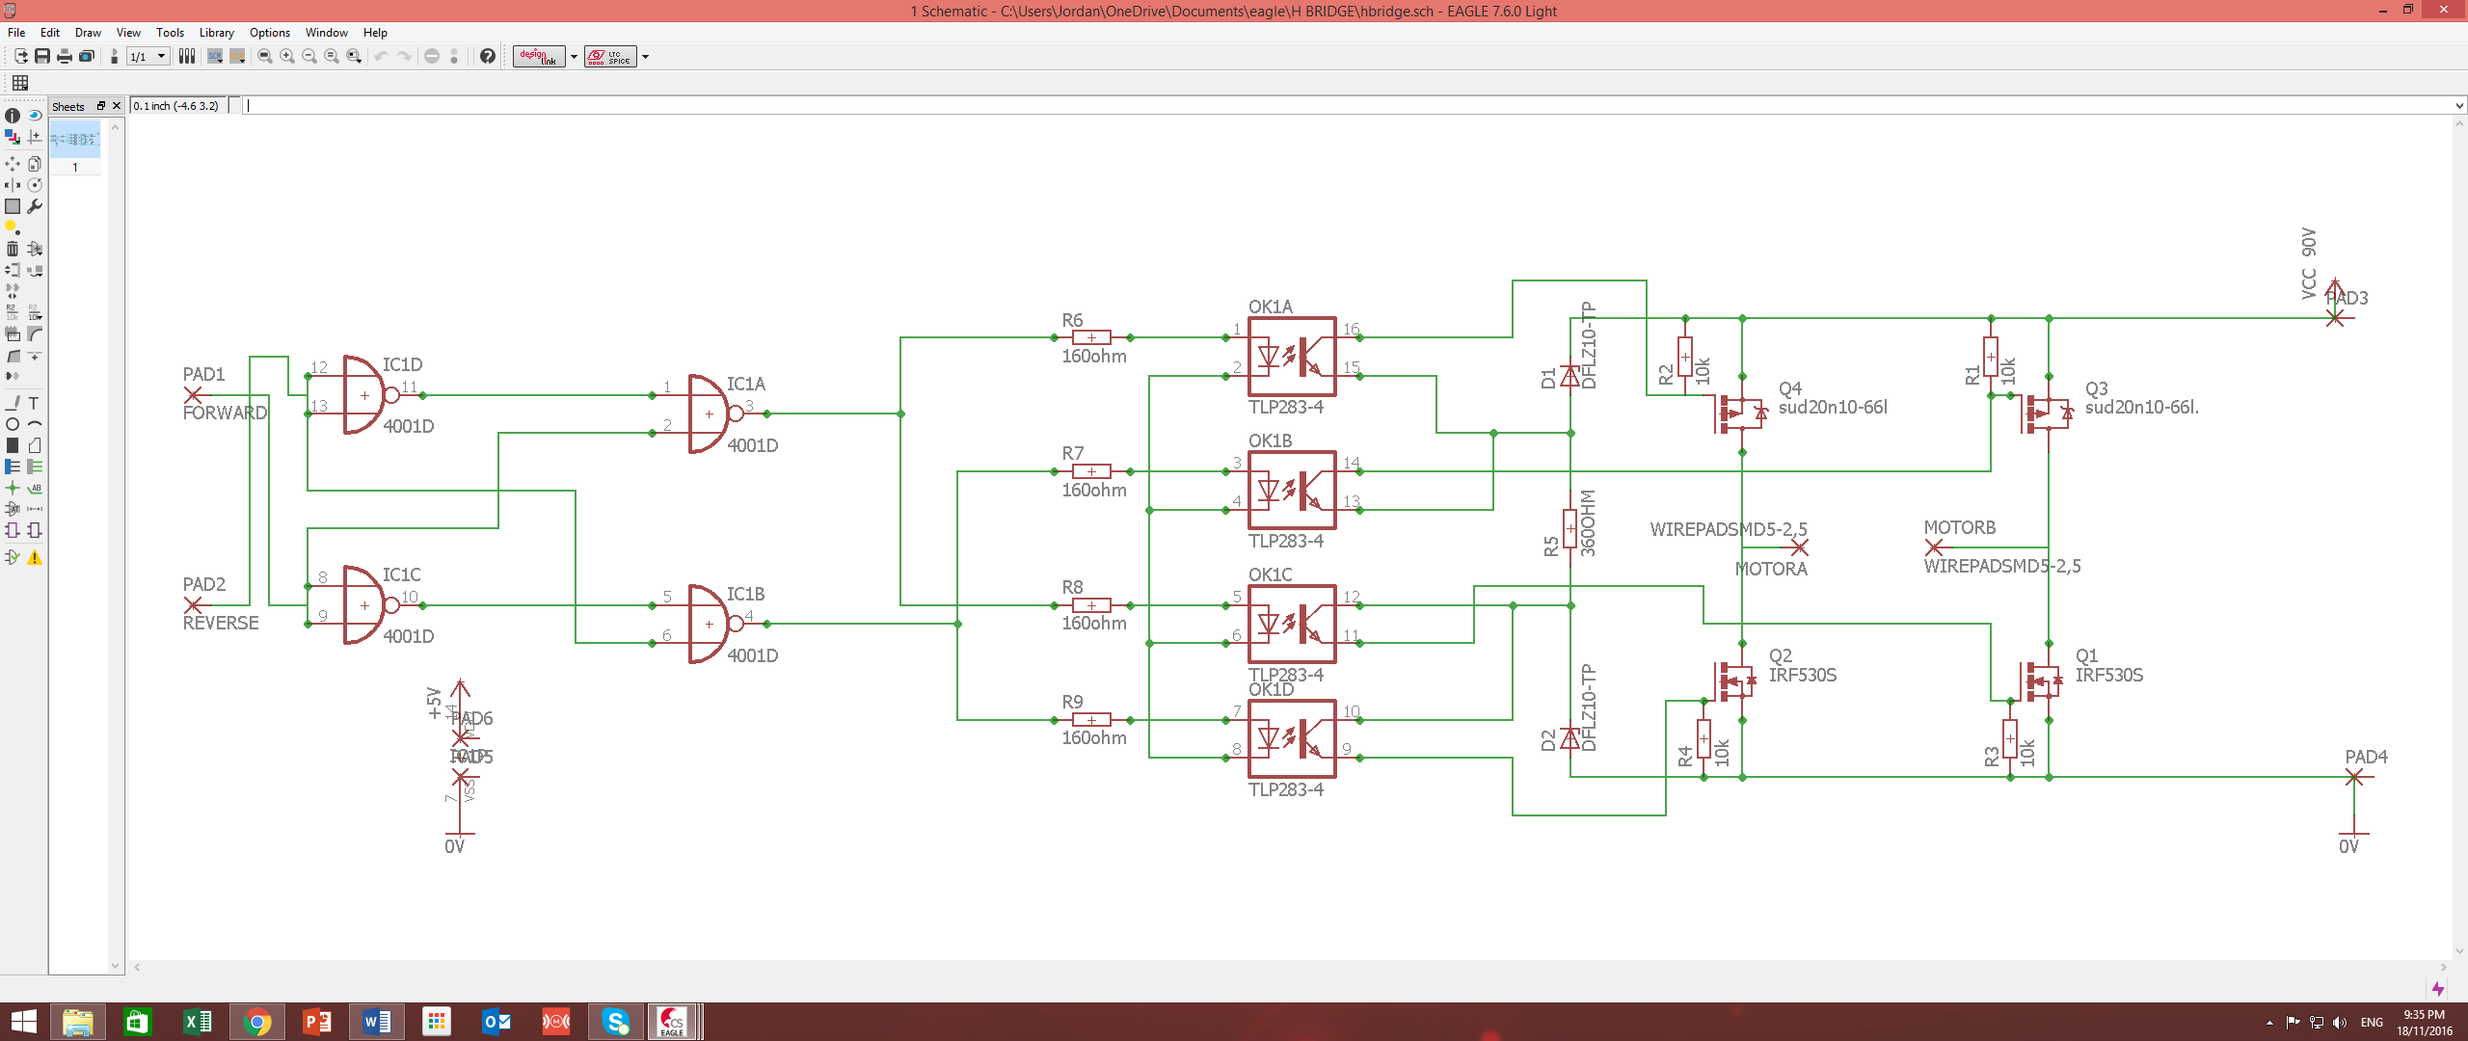

ii/ Multisim schematic

